Check Internet (beta)
These last three months we have experienced internet connection slowdowns in several UniField instances. The internet connection seems to work well but UniField struggles to fetch patches and to synchronize.
Thanks to our investigation, we have noticed that some internet providers limit bandwidth per port. This technique is called bandwidth throttling.
Unfortunately, the tools we have used to ensure that port 8071 is open fail when they face bandwidth throttling. Check Internet is a new tool to detect if such technique is enabled by an ISP. It analyzes bandwidth using several different ports including the one used by UniField.

How it works
This tool fetches a patch from a server close to the production SYNC_SERVER. It then checks that the patch is not corrupted and gives you the bandwidth available when downloading it. The patch we use is UniField 2.0.

 | This tool transfers around 10 megabytes of data every time you run it. Please take that into account we you run it. You will be charged by your ISP.

How to run it
Unzip file check_internet_XXX.zip. | 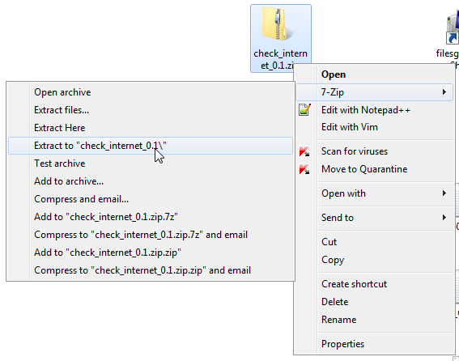
Open the new folder and execute check_internet_connection.exe. | 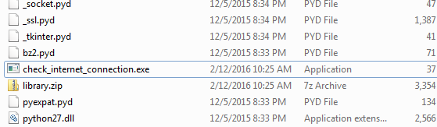
A command prompt opens to show you the results. | 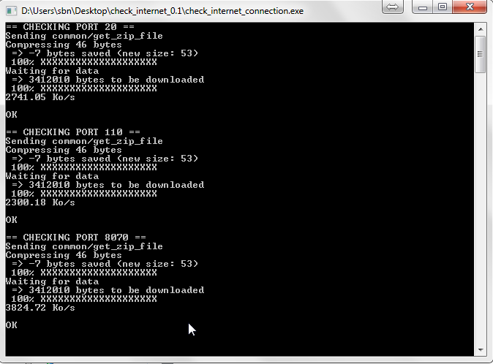
NOTE: This tool uses the Microsoft Visual C++ 2005 Redistributable Package. If it is not installed, you will get an error message at runtime. As this component is installed with UniField, you shouldn’t be worried about this issue.

How to read the results
Check Internet tries to download the same patch on three different ports:  - Port 20 (port used for FTP)  - Port 110 (port used for emails, POP3)  - Port 8070 (default port for UniField’s synchronizations) | Checking port 20  Checking port 110  Checking port 8070
If a port is filtered by the ISP or by a firewall (either locally or by an appliance in your network) you will have the following error message: Error when connecting to uf0003.unifield.org.  If port 8071 is filtered, UniField won’t be able to connect.  If this error message is displayed for every port, your internet connection could be the culprit. Try to browse a web site to check it. | 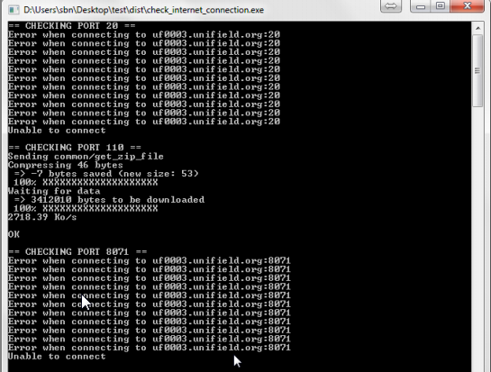  Port 20 seems to be filtered  Port 8071 seems to be filtered. UniField won’t work!
Bandwidth throttling can also be detected by the tool.  This screenshot comes from a UniField instance in Kenya. Bandwidth on port 8070 is filtered. This behavior has caused the following issues:  - slow synchronization  - failure when upgrading UniField  Please pay attention to the fact that these results can vary a lot between two runs. Run it several time to get accurate results. | 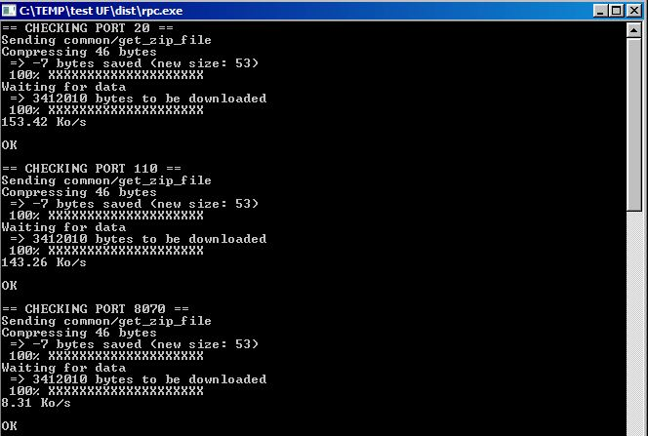  Port 8071 is 16 times slower than the “standard” ports.

What to do next?
If you are sure that the error isn’t local, you can ask the local ISP if he is aware of such technics. Up to now this method hasn’t proved successful. The last options are to:
- change your internet provider.
- use another port to synchronize this instance. This option is not available at the moment but we are working on it to give you this possibility.

